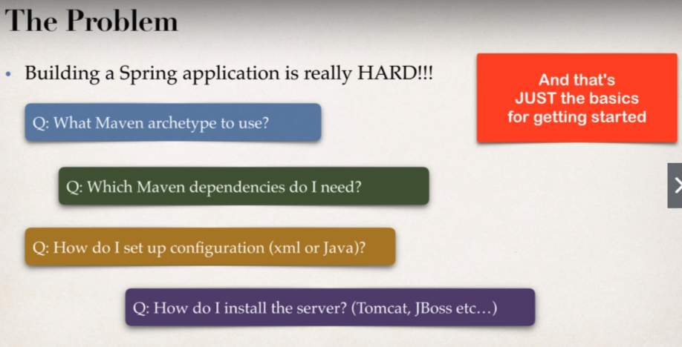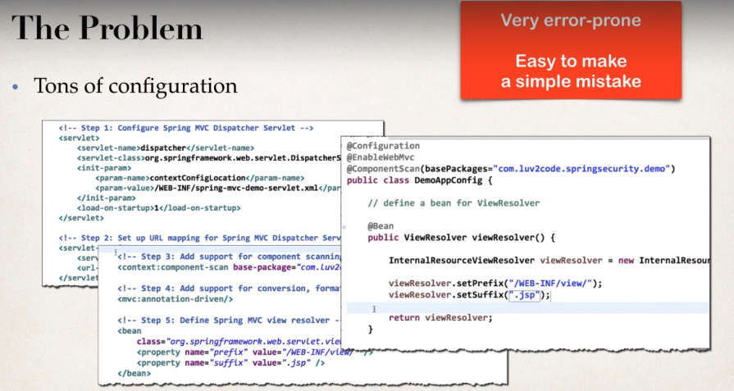

**Spring Boot** is the solution:

* Make it easier to get started with spring development.
* Minimize the amount of manual configuration
* Perform auto-configuration based on props files and JAR Classpath.
* Help to resolve dependency conflicts (Maven or Gradle)
* Provide an embedded HTTP server so you can get started quickly.
* Out of box we can make use of Tomcat, Jetty, Undertow,…

Spring boot provides the spring initializer, which helps to quickly create a starter Spring Project.

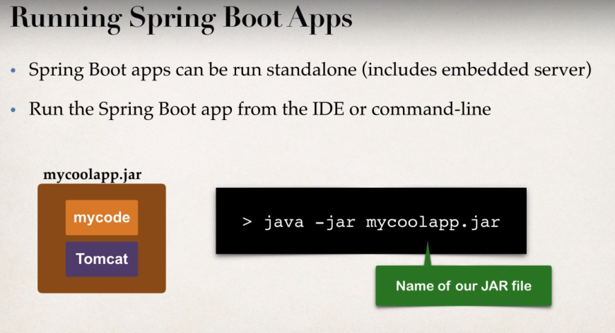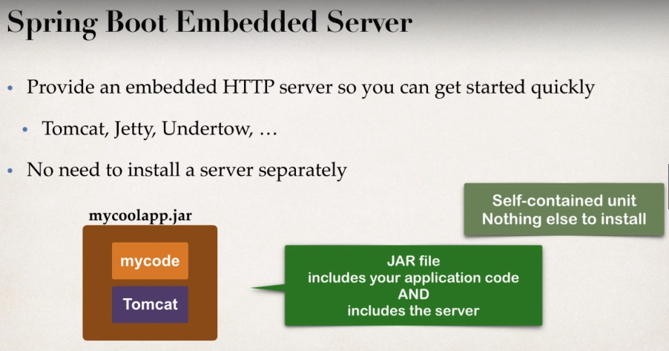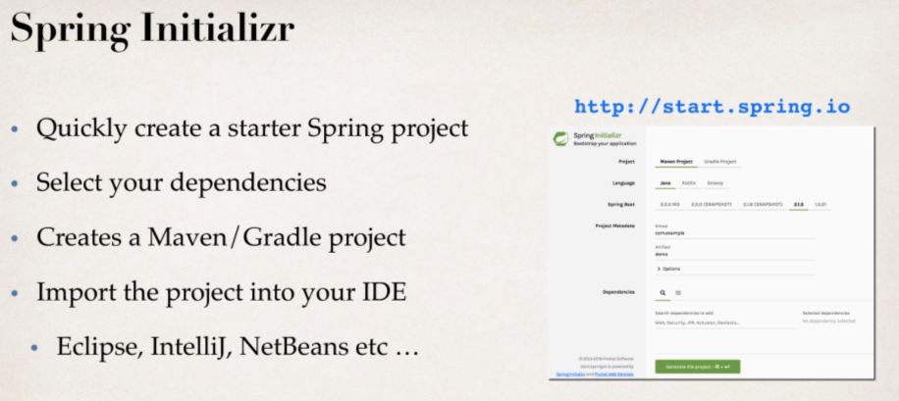

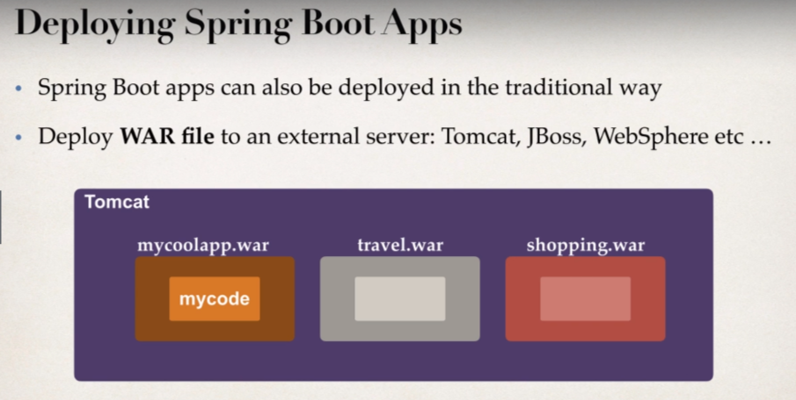

* 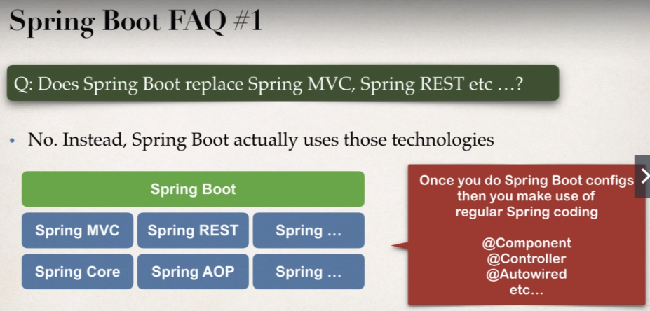**Spring Boot Initializer Demo**

1. Configure our project at Spring Initializer website

Visit the website: <https://start.spring.io/>

1. Download the zip file
2. Unzip the file
3. Import Maven project into the IDE.

We will go to the file annotated with **@SpringBootApplication** annotation and run as **java application.**

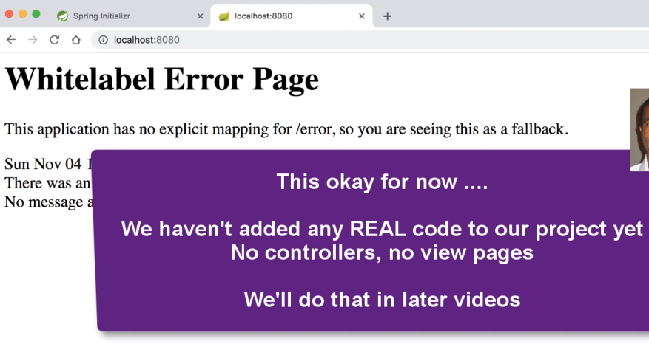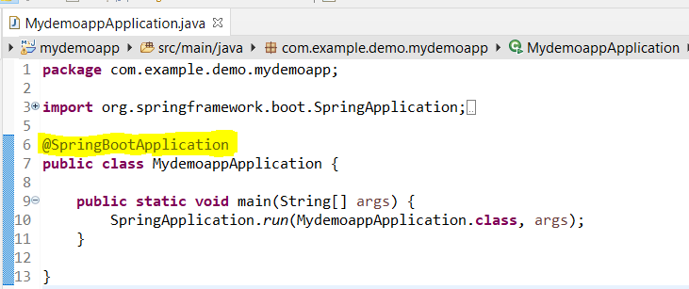

**Output:**

* 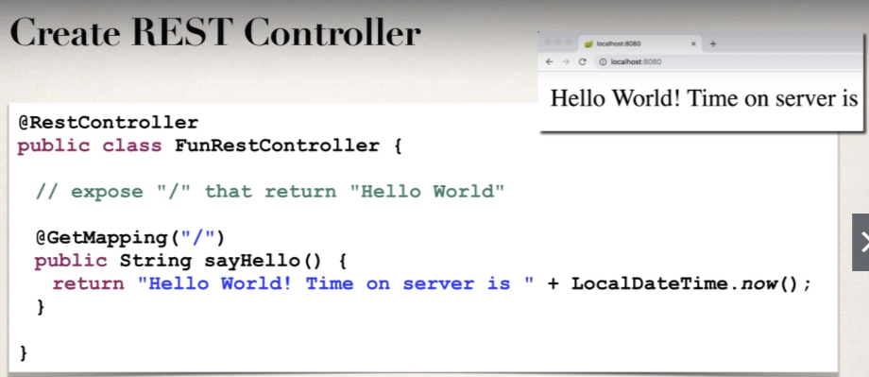**Create a REST controller with Spring Boot**

**Output**:

So, within no time we have successfully made our rest application and without performing any configuration.

* **Exploring Spring Boot Project Structure:**

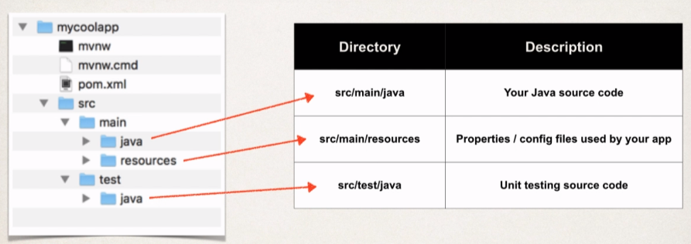Spring boot make use of **Maven Standard Directory Structure.**

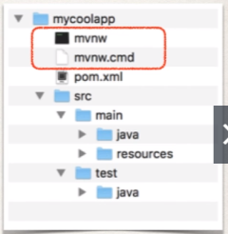**Maven Wrapper files:**

* **mvnw** allows you to run a Maven Project.
* And there is no need to have Maven installed or present on your classpath.
* What they will do actually:
* If correct version of Maven is NOT found on your computer
* Then it will **Automatically Downloads** correct version and runs Maven.
* There are two files that are provided:
* **mvnw.cmd** for MS windows.
* **mvnw.sh** for linux/Mac
* If you already have Maven Installed previously.
* 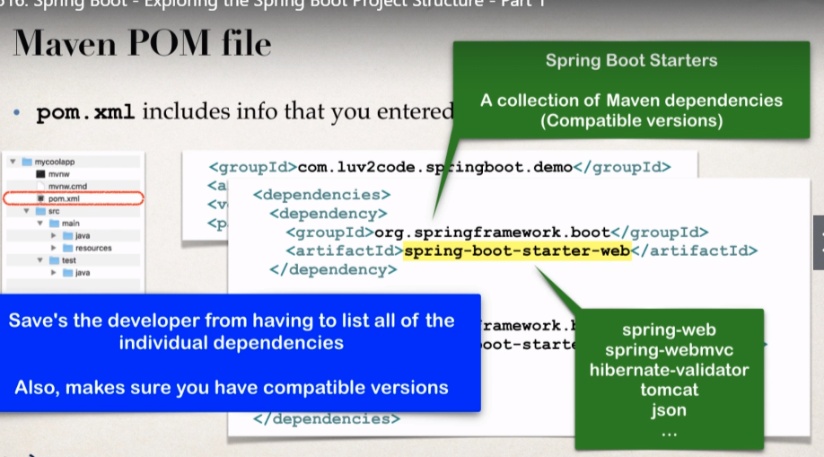Then you can simply ignore/delete the **mvnw** files.

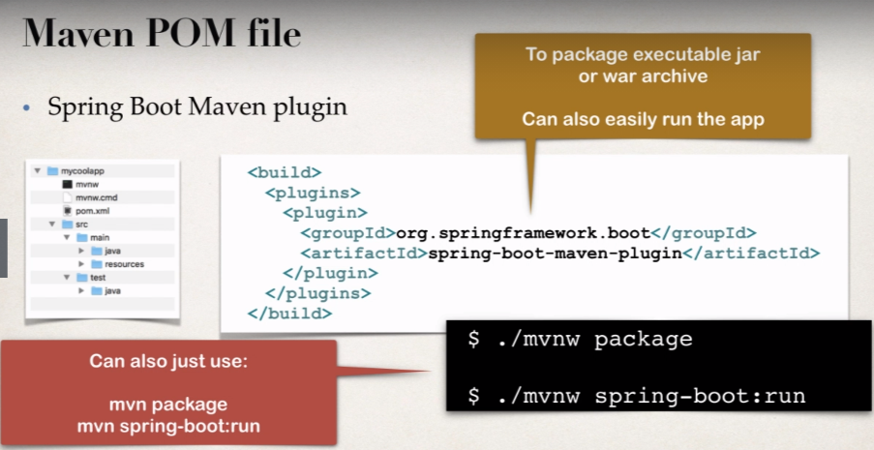

If maven is already installed in our system, then we can just use the below two commands:

**mvn package**

**mvn spring-boot:run**

**Main Spring boot application class Created by Spring Initializer:**

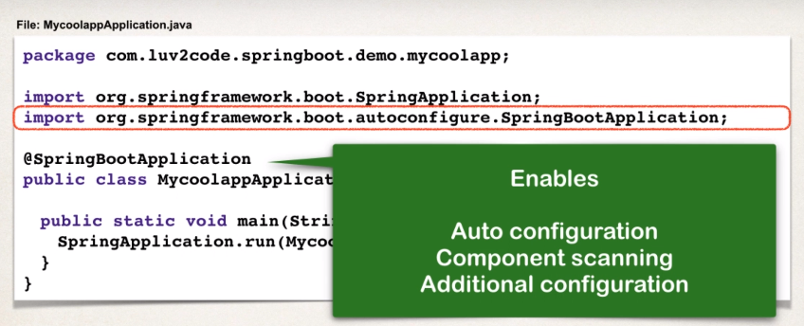

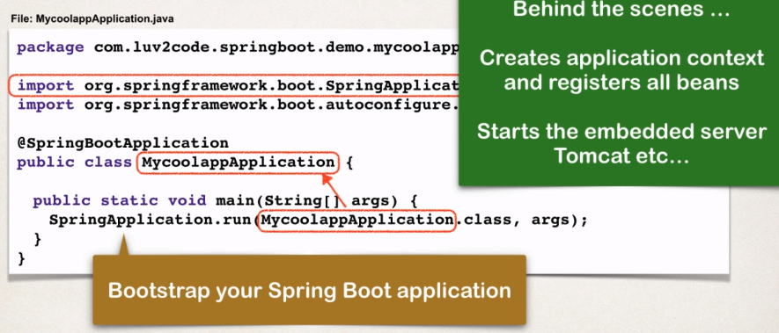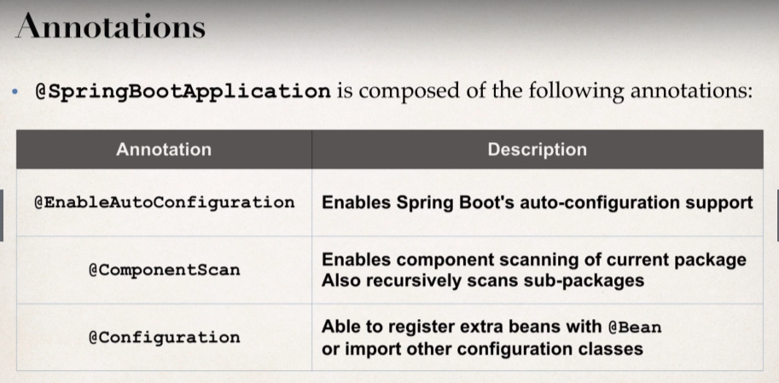

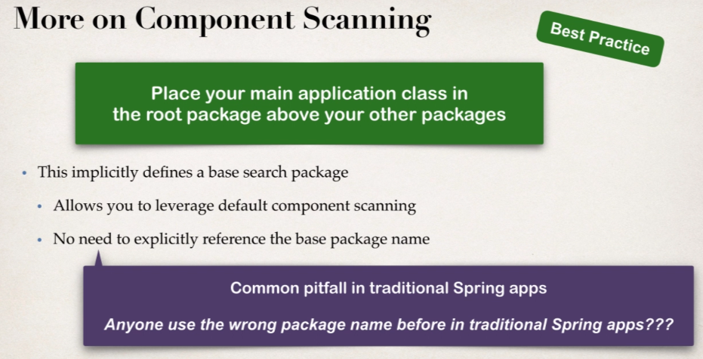

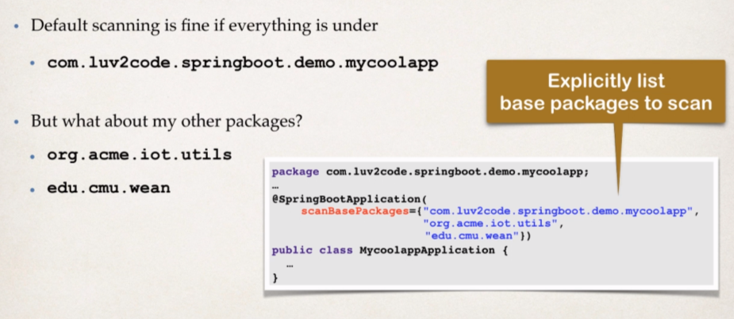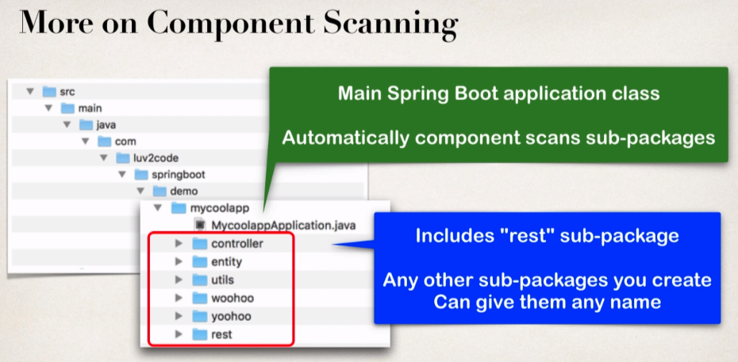

* **Application Properties:**

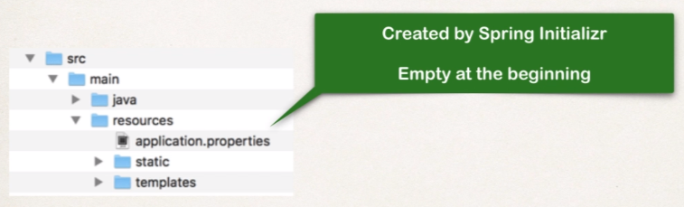By default, Spring Boot will load properties from: **application.properties**

How to read data from **Application.properties** file:

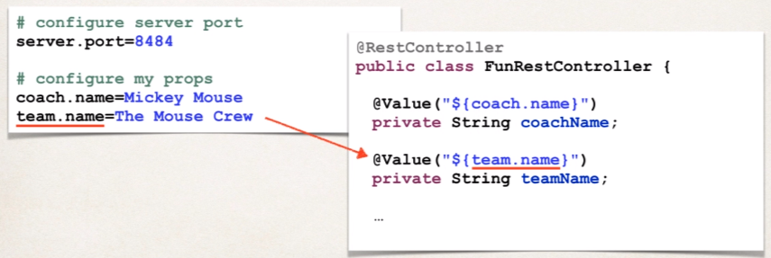We can actually read this by making use of **injection**.

* 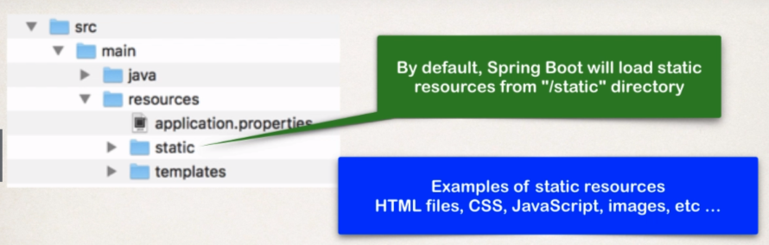**Static Content**

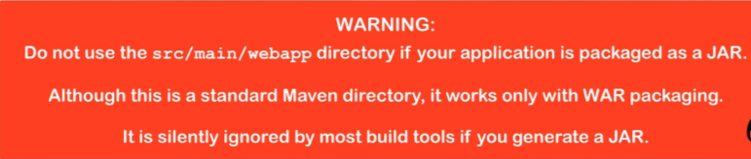

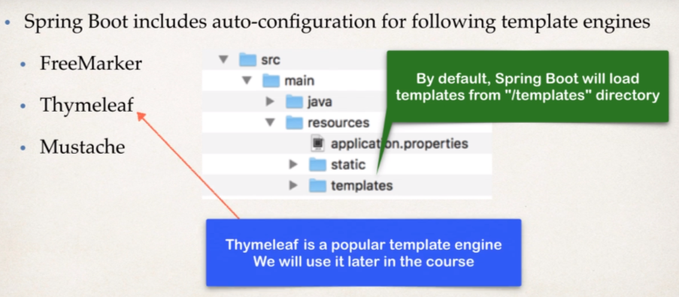**Templates**

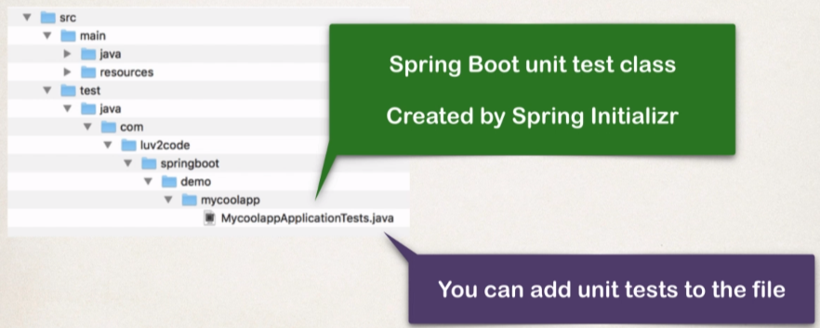**Unit Tests**

* **Spring Boot Starters:**
* A curated list of Maven Dependencies.
* A collection of dependencies grouped together.
* Tested and verified by the Spring Development team.
* These starter makes it much easier for the developer to get started with spring.
* Reduces the amount of Maven configuration that we need to do.

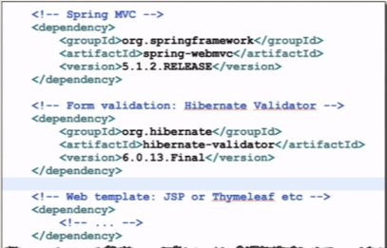Let’s consider an example of **Spring MVC**:

So, to build a Spring MVC app, you normally need dependencies;

* Spring MVC
* Hibernate validator for some form validation
* And for a given web template, we need to put the dependency.

**Here is the solution**:

Spring boot provides: **spring-boot-starter-web**

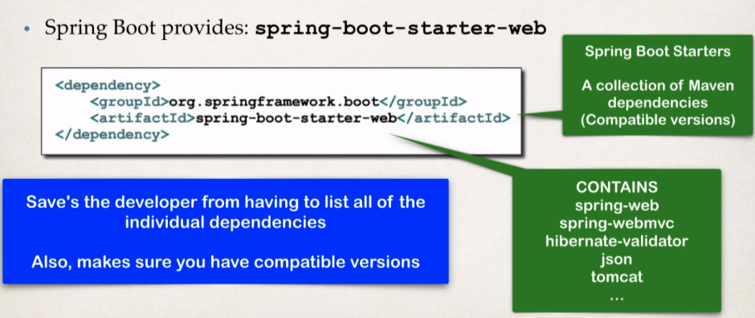Add this Maven dependency to the Maven pom file. And this dependency entry actually contains other dependencies as it contains spring-web, spring-webmvc, hibernate-validator, json, tomcat.

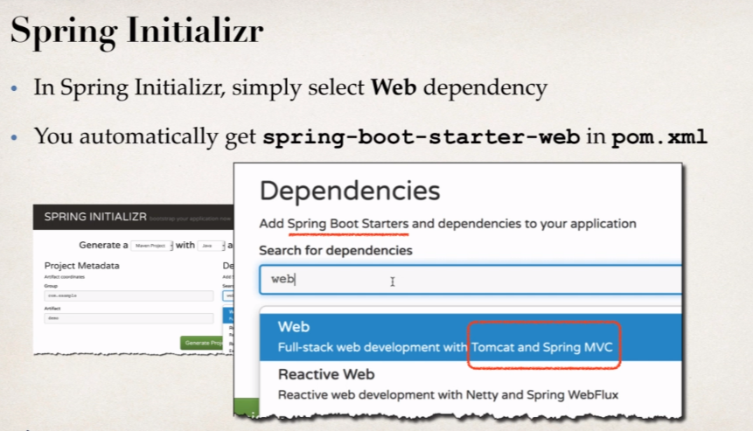So, in the spring initializer we need to select web dependency:

**Another Example:**

* Support we are building a Spring app that needs: Web, Security.
* Simply select the dependencies in the Spring initializer.
* 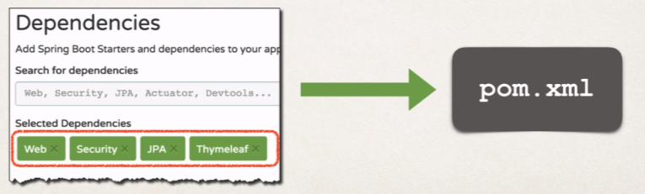It will add the appropriate Spring Boot starters to your pom.xml.

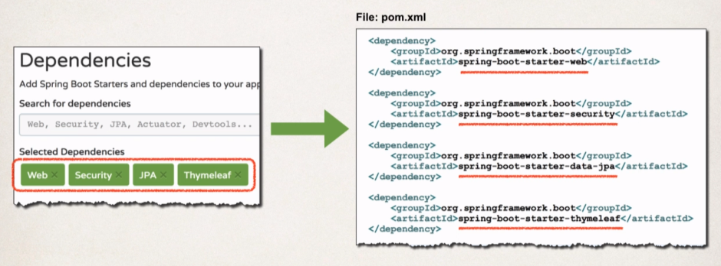

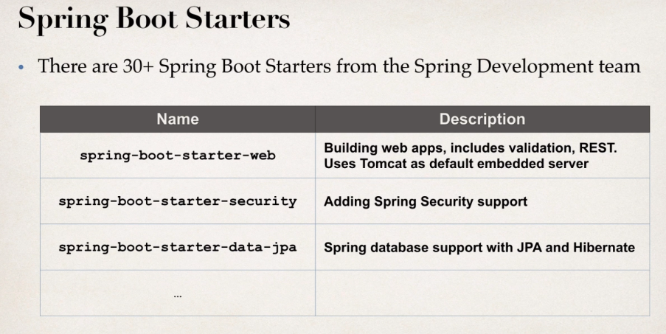

If we want a **full list** of Spring boot starters: [Link](https://docs.spring.io/spring-boot/docs/current/reference/htmlsingle/#using-boot-starter)

* 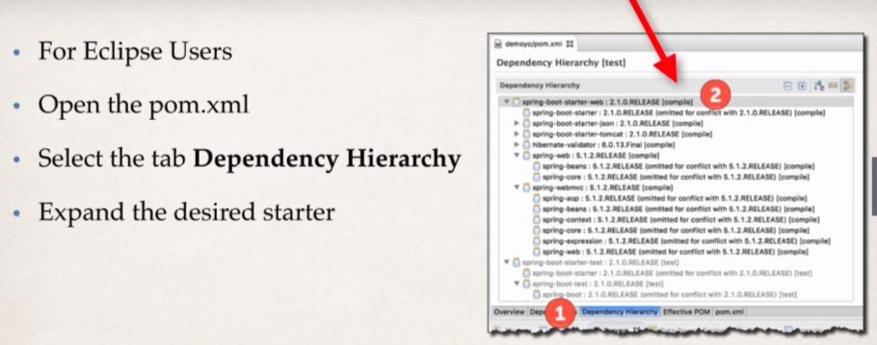**What is in the Starter dependency that we have just into pom.xml?**

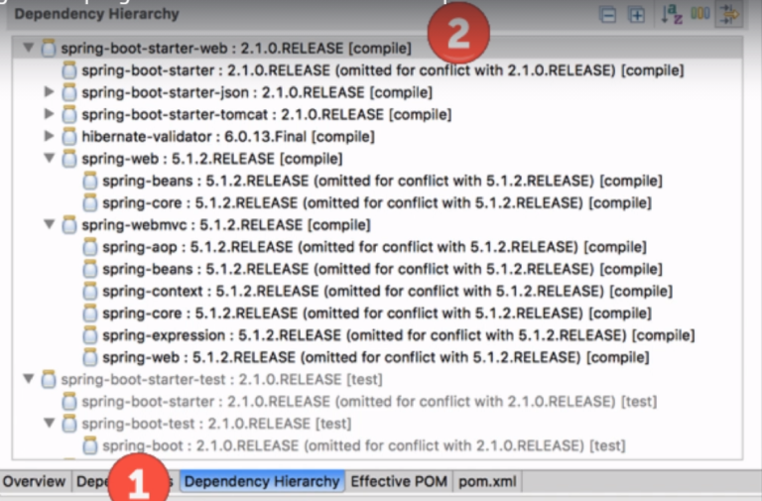**Ecilipse Way:**

* **Spring Boot Starter Parent:**

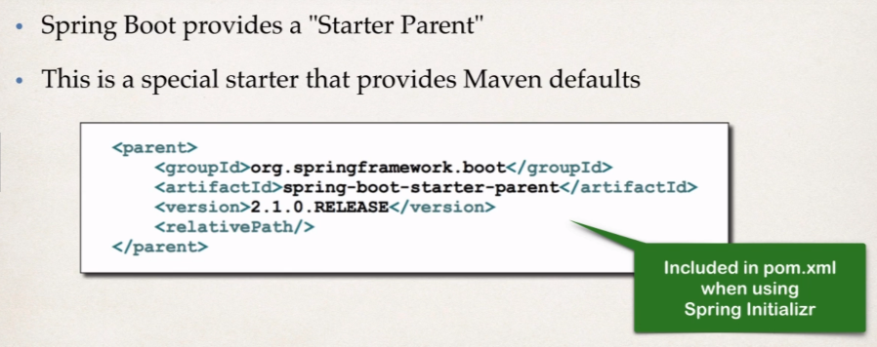

So, the Maven Defaults are actually defined in the Starter Parent.

* We get the Default compiler level
* Also have support for UTF- 8 source coding
* Others..

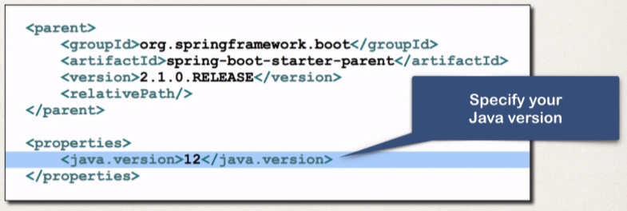To override a default, set as a property

For ex in our project, we want to use java 12, or 15. then we can simply override that property.

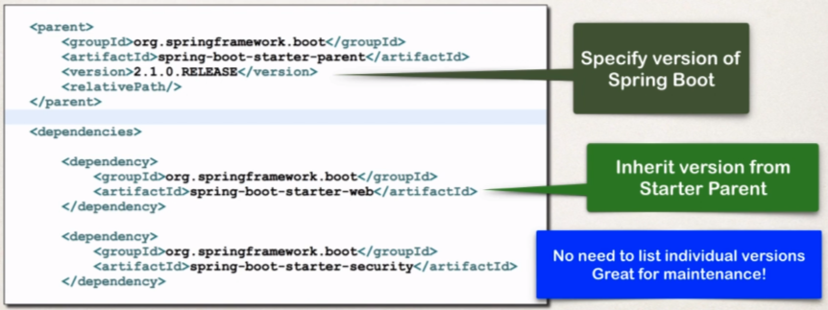For **spring-boot-starter-\*** dependencies, no need to list version.

Basically, we have here **spring-boot-starter-parent** where we specify the version that we are using and then for the actual dependencies, we simply inherit the version from the starter parent. So, there is no need to list individual versions and it’s great for maintenance.

Starter parent also provides the default configuration of Spring boot plugin, in our build section of pom.xml file, we simply refer to the spring boot maven plugin and that’s it. And now we can simply run it from our command line using the command:

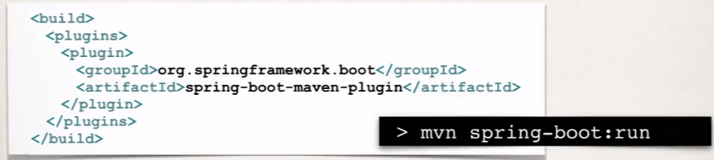 **mvn spring-boot:run**

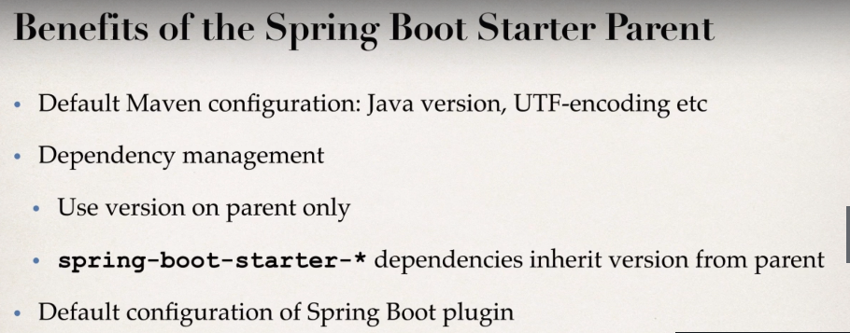



**The Problem:**

When running Spring Boot applications.

If we make changes to our source code, then we have to manually restart our application.

**Solution: Spring boot Dev Tools**

* **Spring-boot-devtools** to the rescue!
* Simply add the dependency to your pom.xml.

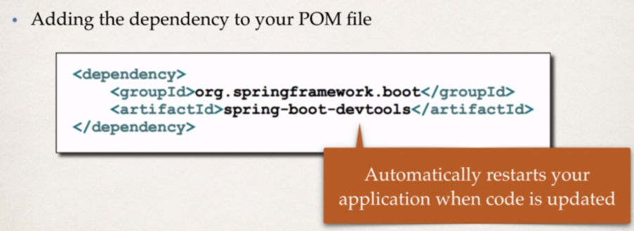

**Spring boot Actuator** [Java Project Link](https://github.com/000GEV744/Spring-Git/tree/main/02-spring-boot-actuator-demo)

**Problems:**

* How can I monitor and Manage my application?
* How can I check the application health?
* How can I access application Metrics?

**One Solution is:** Spring boot Actuator

* It exposes endpoints to monitor and manage your application
* You easily get DevOps functionality
* Simply add the dependency to your POM file
* 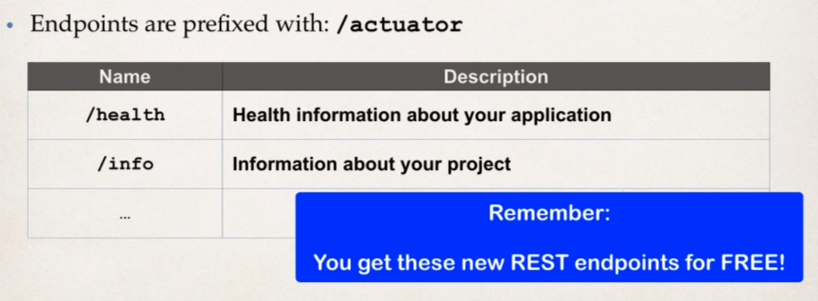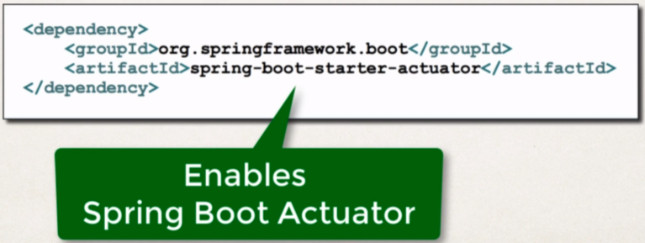REST endpoints are automatically added to your application.

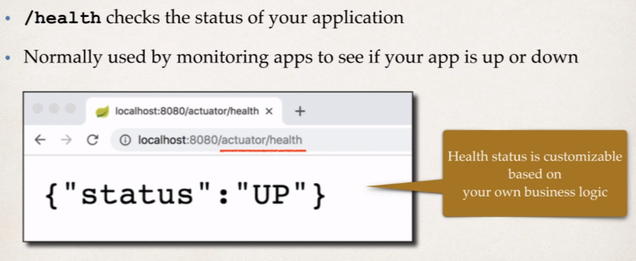

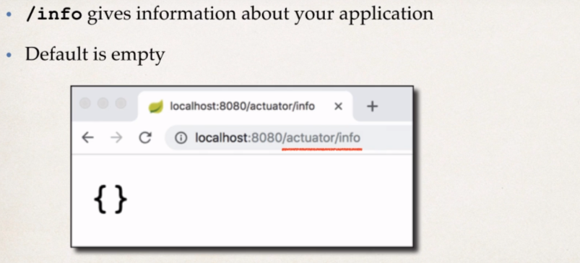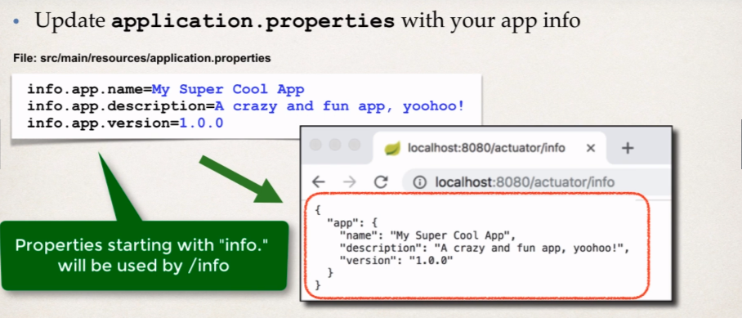So, we can customize this “/info” endpoint.

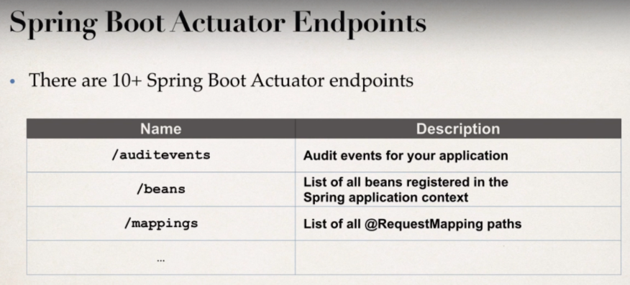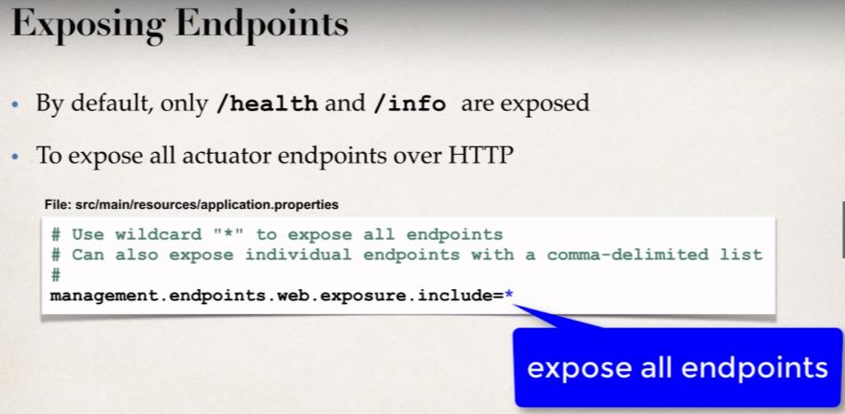

Development Process:

1. Edit pom.xml and add **spring-boot-starter-actuator**
2. View actuator endpoints for: **/health** and **/info**
3. 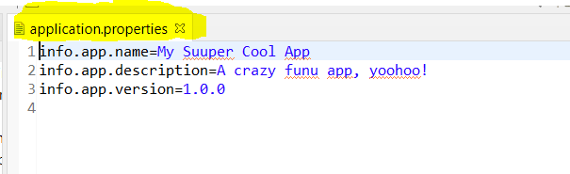Edit **application.properties** to customize **/info**.

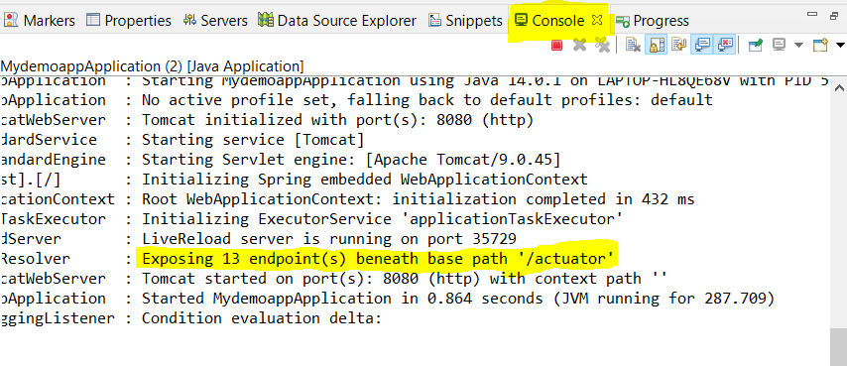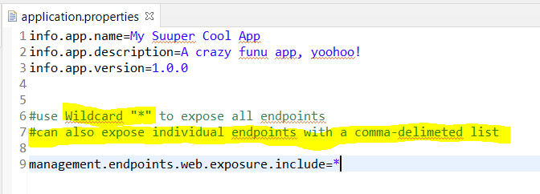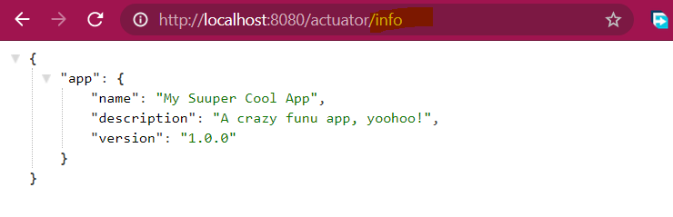**Exposing all the other Endpoints of Spring Boot Actuator**

We can test then using endpoints:

<http://localhost:8080/actuator/mappings>

<http://localhost:8080/actuator/beans>

<http://localhost:8080/actuator/threaddump>

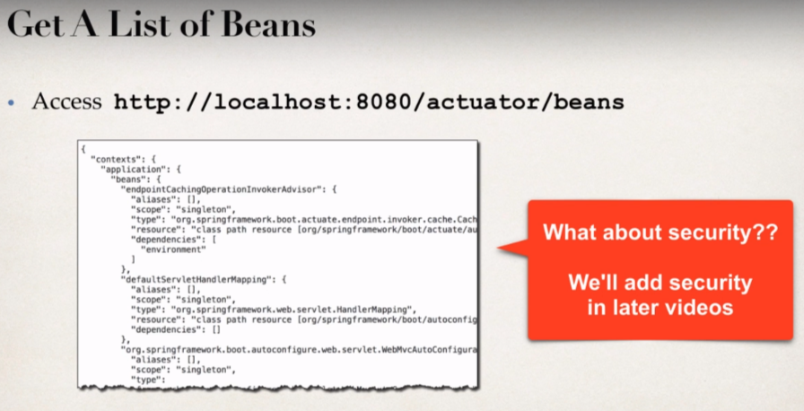

**Spring Boot Actuator Security:**

Previously we learn how to expose all the spring boot actuator endpoints and we must be thinking about security,

We may not want to expose all of the endpoint information to anyone.

We will add Spring Security to project and endpoints are secured.

We need spring-boot-starter-security dependency.

**Secured Endpoints:**

* Now when we access: /actuator/beans
* Spring security will prompt for login

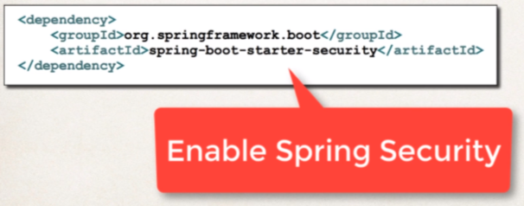We can also override default username and generated password:

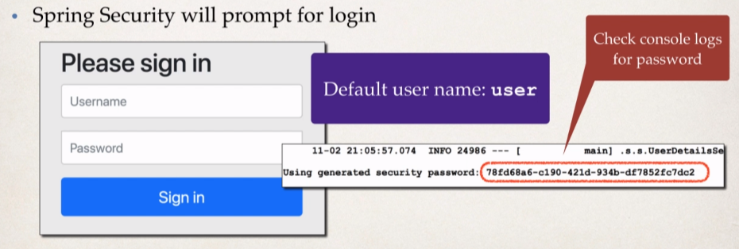

In the **application.properties** file:

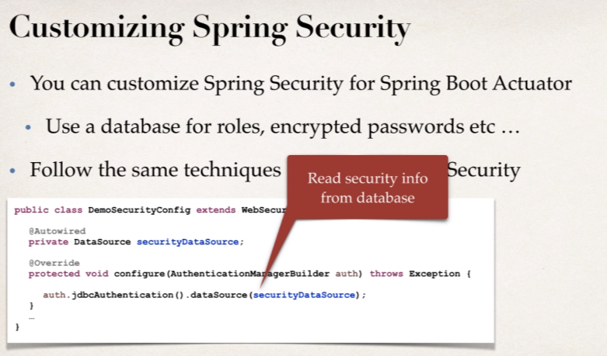

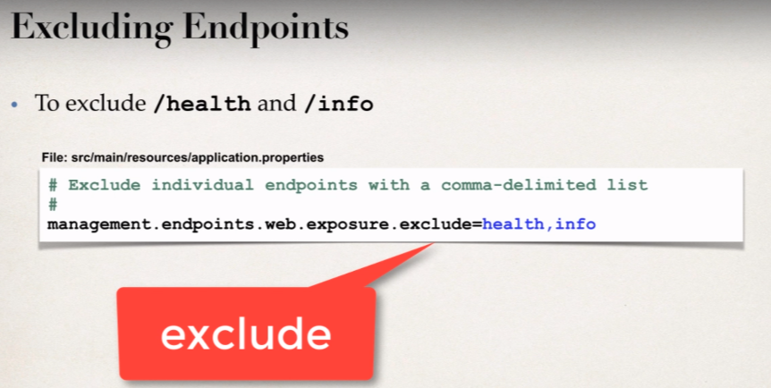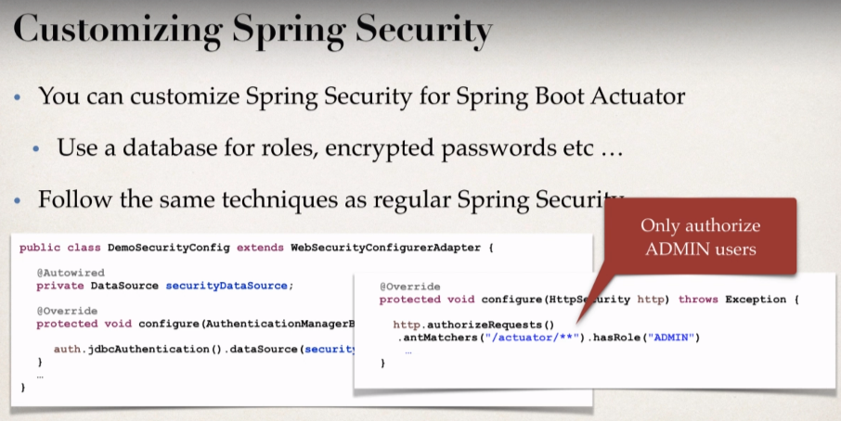

**Development Process:**

1. Edit pom.xml and add **spring-boot-starter-security**
2. Verify security on actuator endpoints for: **/beans** etc.
3. Disable endpoints for **/health** and **/info**.

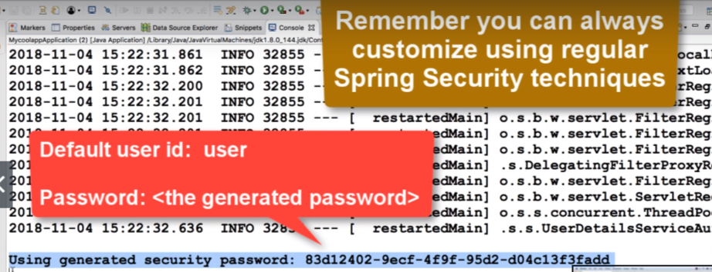

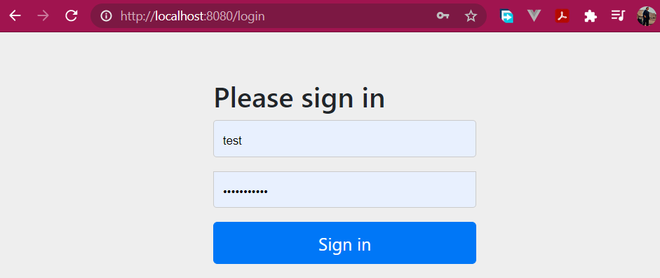On hitting the endpoints: <http://localhost:8080/actuator/mappings>, we will get to see this login page.

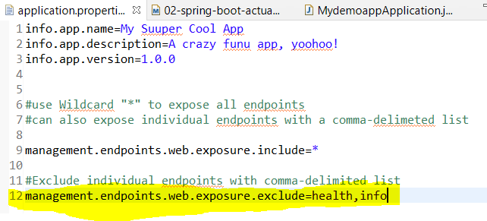But by default, /health and /info will not be secure so we will disable those endpoints.

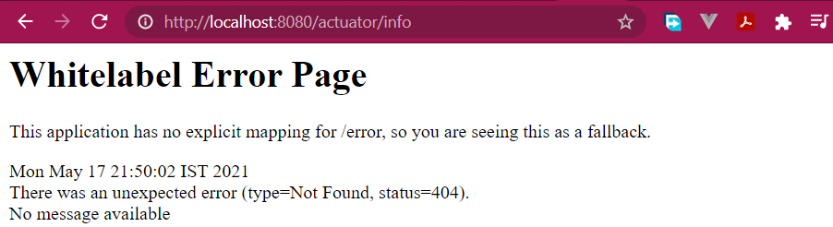**Now /health and /info will not be available anywhere.**



**Overview:**

Running from the Command-Line:

* No need to have IDE open/running
* Since we are using Spring Boot, the server is embedded in our JAR File.
* So, there is no need to have separate server installed/running
* 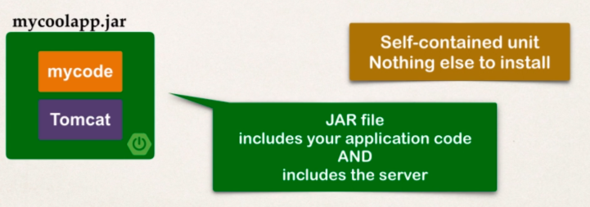Since our spring boot apps are self-contained.

Two Options for running the app:

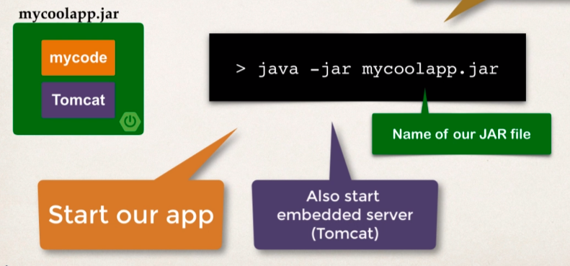Option 1: User **java -jar**

Option 2: Use Spring boot maven Plugin

**mvnw spring-boot:run**

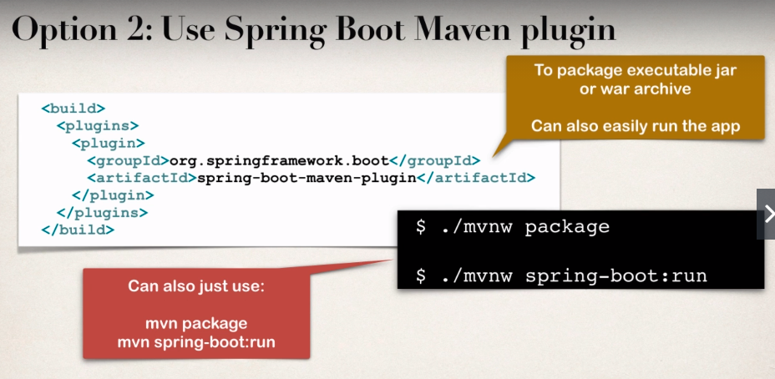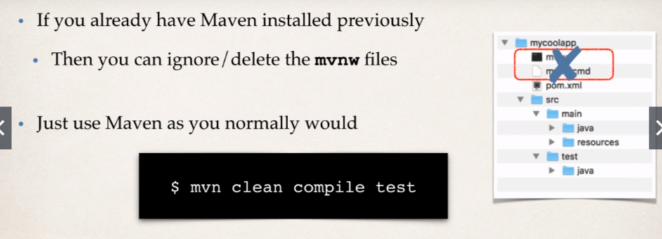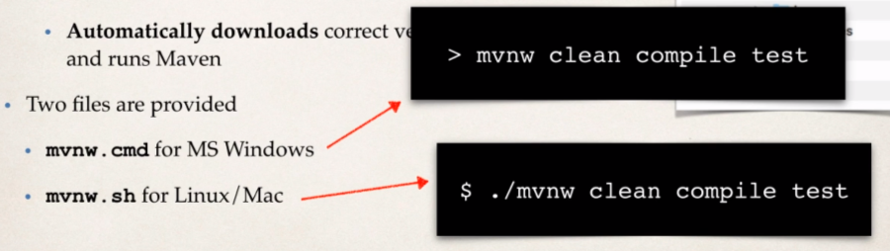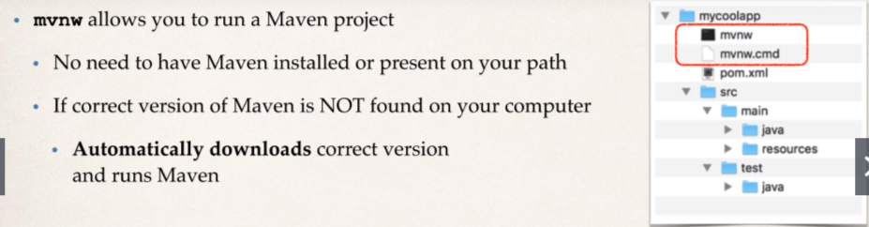

**Development Process:**

1. Exit the IDE
2. Package the app using **mvnw package**
3. Run app using **java -jar**
4. Run app using spring boot maven plugin, **mvnw spring-boot:run.**

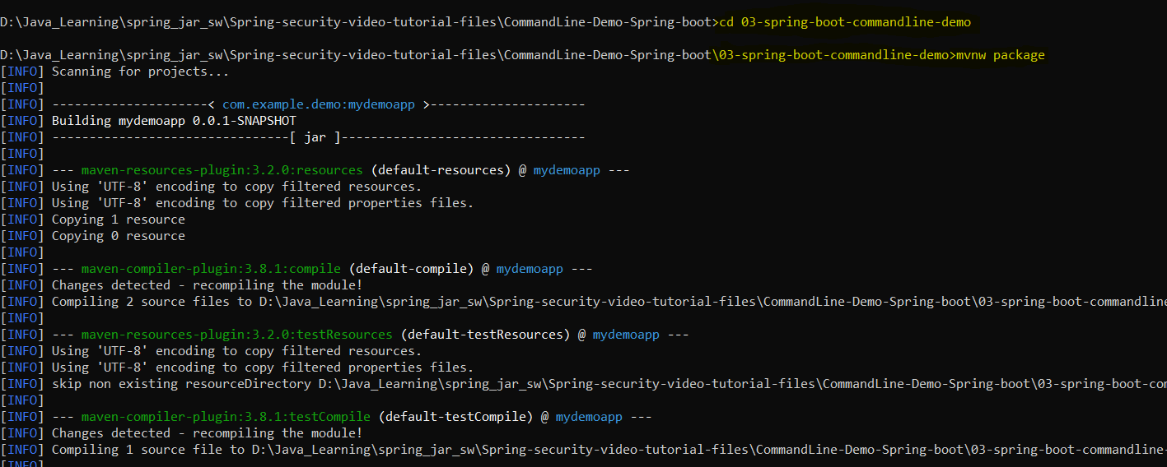**Go to the directory where the app is present then;**

Using **mnvw package** command to build the JAR File.

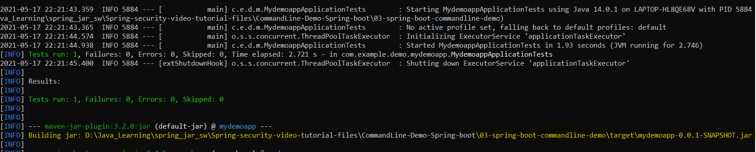And the jar file will be created into the **Target** subdirectory:

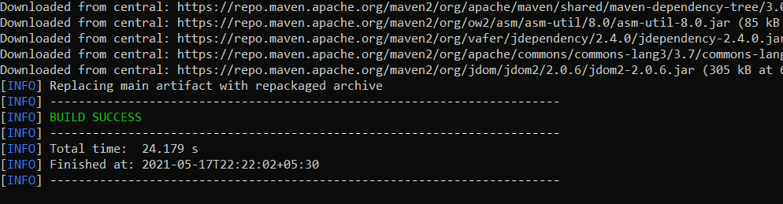**And in the end, we will see BUILD SUCCESS log:**

Now move into the **target** subdirectory:



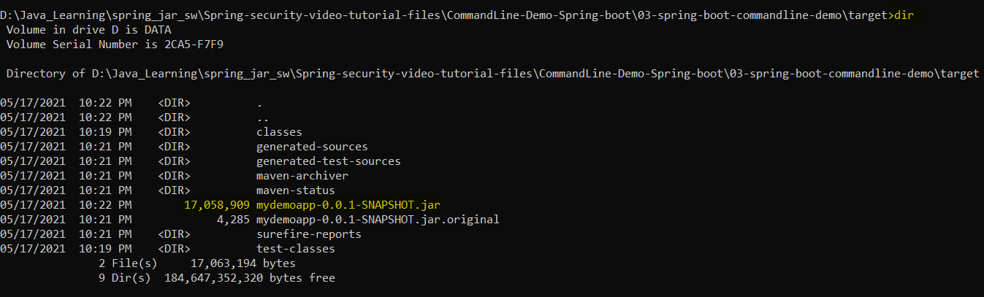Now we need to run the created jar file:

Using the command **java -jar mydemoapp-0.0.1-SNAPSHOT.jar**

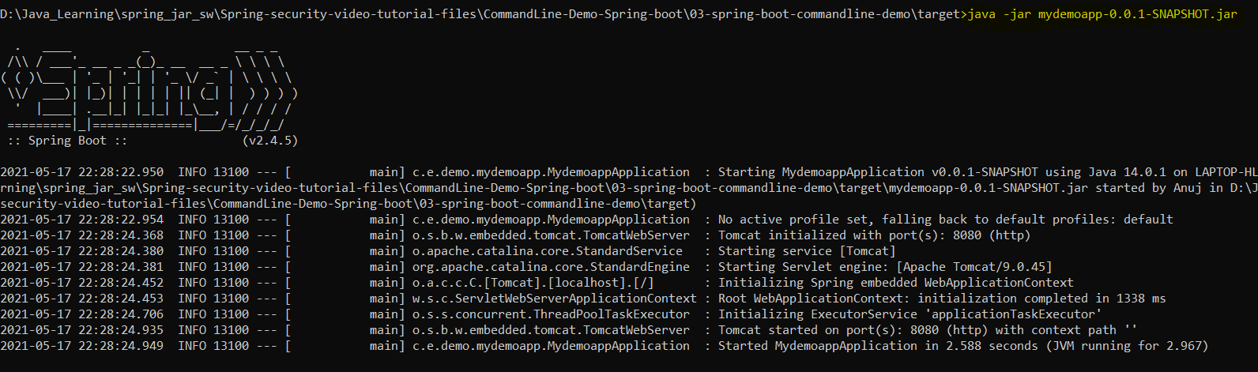And it runs the application on cmd.

Now to run via spring boot maven plugin:

* **cd..**
* go to application folder; use command: **mvnw spring-boot:run**

And this will run the application.

* **Spring Boot Properties:**

1. Spring Boot can be configured in the application.properties file.
2. Server port, context path, actuator, security etc

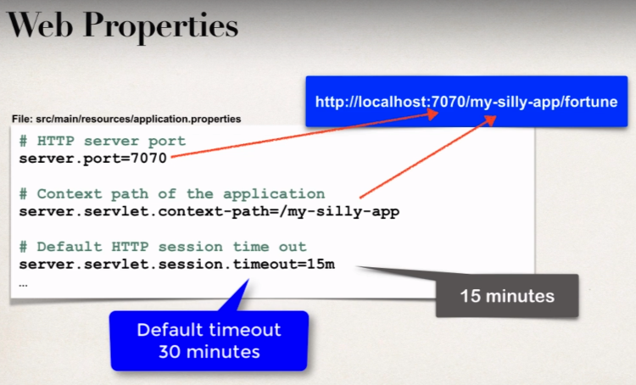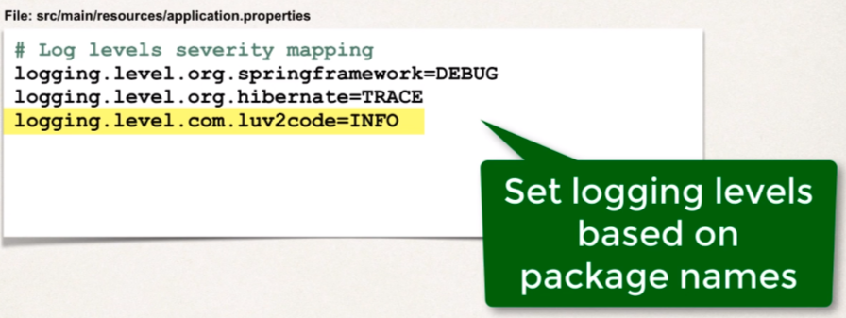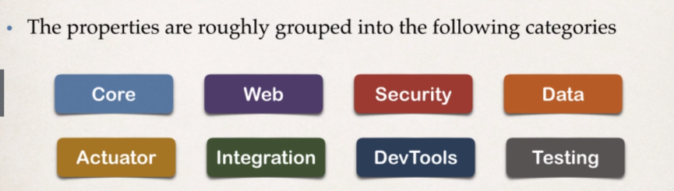

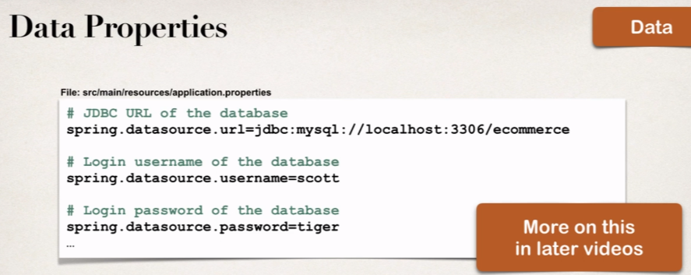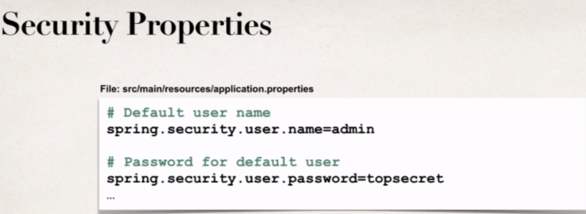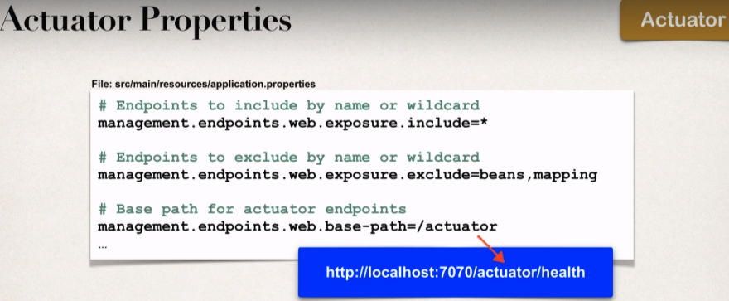

* **Spring Employee CRUD Operations:**

**For setting up DAO service:**

In traditional Spring

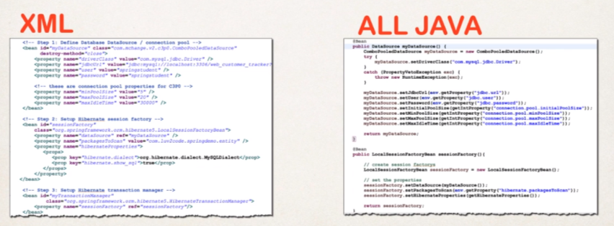We normally had to do this configuration manually;

So, there should be easier solution to do all this as this is very error prone.

**Spring boot comes to the rescue:**

* Spring boot will automatically configure your data source for you.
* Based on entries from Maven pom file:
* JDBC Driver: **myql-connector-java**
* Spring Data (ORM): **spring-boot-starter-data-jpa**
* DB connection info from **application.properties**

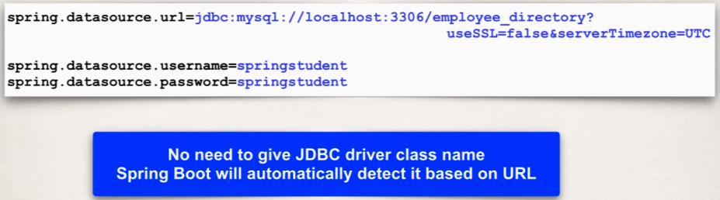So, spring boot will actually create all these info to create data source for us.

There is additional data source properties that we can set:

Properties are available to configure connection pool etc.

[Link](https://docs.spring.io/spring-boot/docs/current/reference/html/appendix-application-properties.html#common-application-properties-data) to follow more about spring boot properties. And go to **spring.datasource.\***

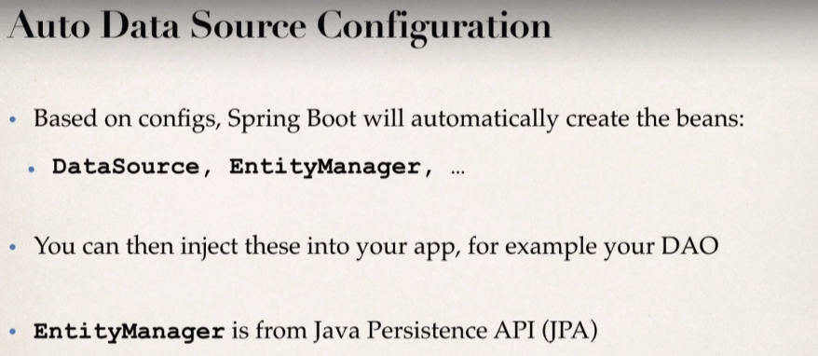

What is **JPA**?

* **Java Pesistence API (JPA)**
* Standard API for Object-to-Relatioinal-Mapping (ORM)
* It’s only a Specification
* Defines a set of interfaces
* 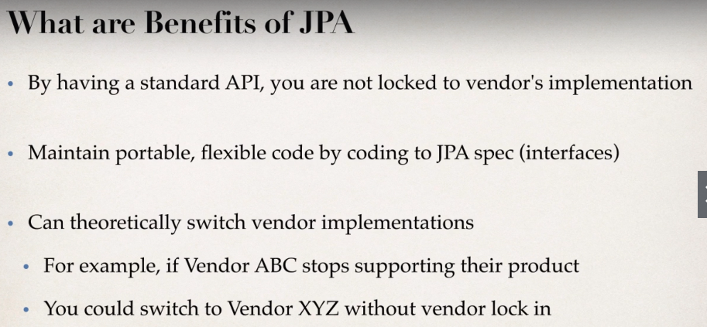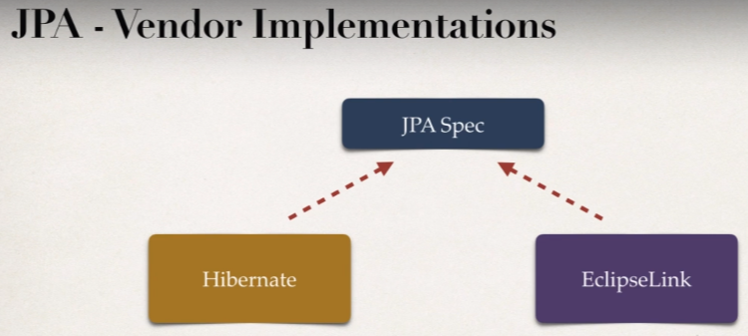Requires an implementation to be usable
* In spring Boot, **hibernate** is default implementation of JPA.
* **EntityManager** is similar to Hibernate **SessionFactory**.
* **EntityManager** can serve as a wrapper for a hibernate **Session** Object.
* So, in our code we can inject **EntityManager** into our **DAO**

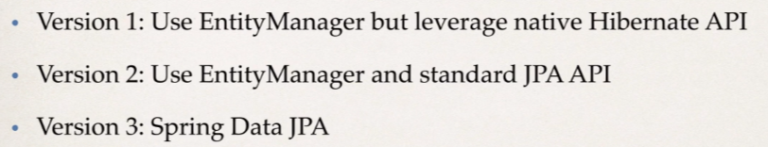**Various DAO techniques:**

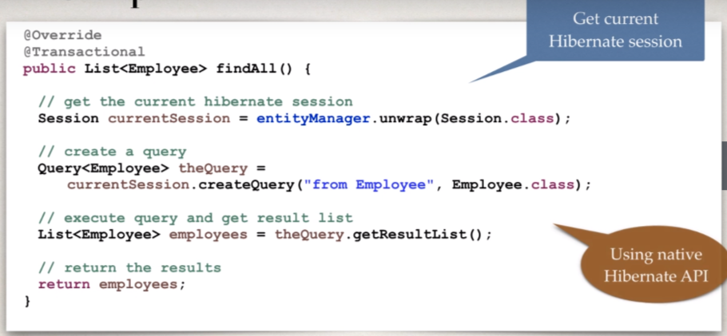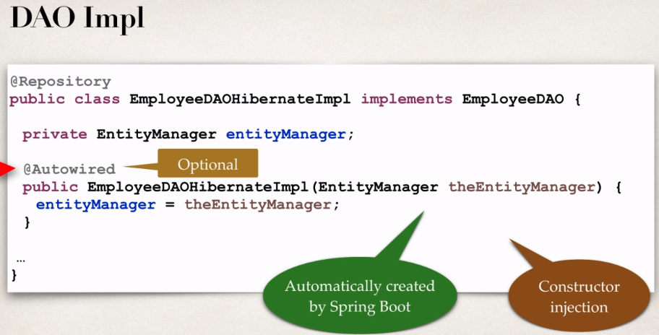**Version 1: Use EntityManager but leverage native Hibernate API** [Java Project link](https://github.com/000GEV744/Spring-Git/tree/main/cruddemo)

**Development Process:**

* 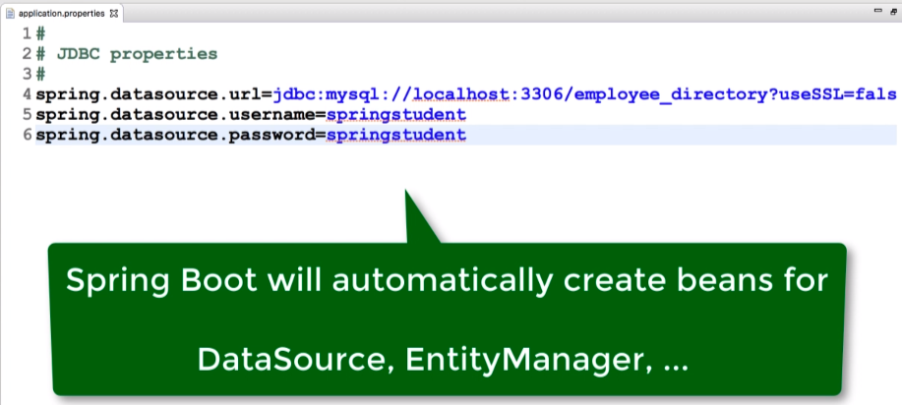Update DB configs in **application.properties**
* Create **Employee** entity
* Create DAO interface.
* Create DAO implementation
* Create REST Controller to use DAO.
* **Create a JPA DAO in Spring boot:** [Java Project Link](https://github.com/000GEV744/Spring-Git/tree/main/22-jpa-cruddemo)

We have already covered version 1: Use EntityManager but leverage native Hibernate API

Here we will focus on the **usage of EntityManager and standard Data JPA API**

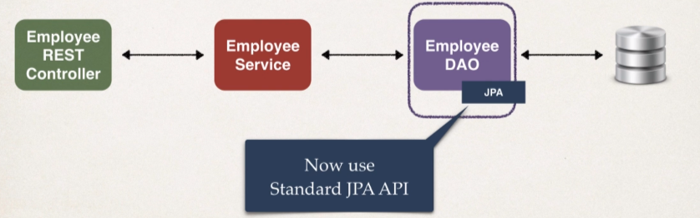

**Benefits of JPA:**

* By having a standard API, you are not locked to vendor’s implementation.
* Maintain portable, flexible code
* Can theoretically switch vendor implementation
* If vendor ABC stops supporting their product, then we can easily switch to vendor XYZ without vendor lock in.

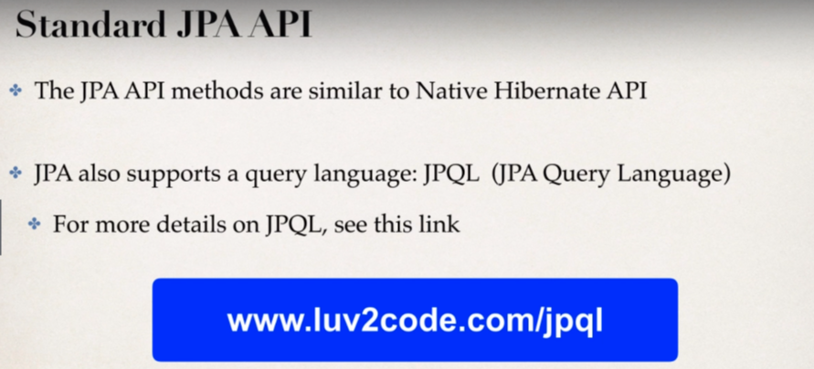

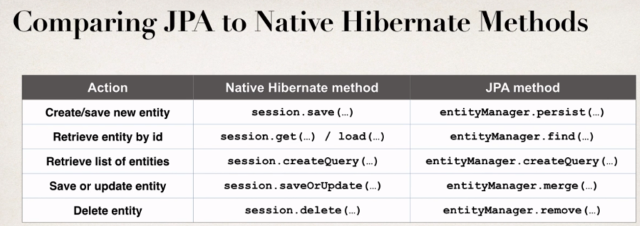

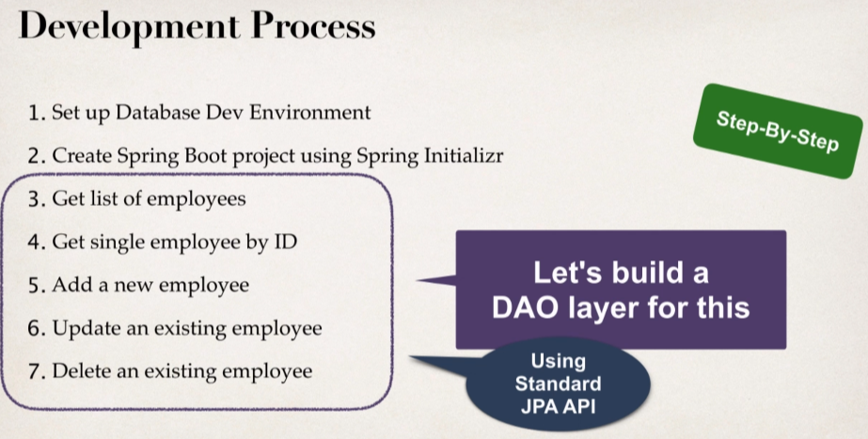

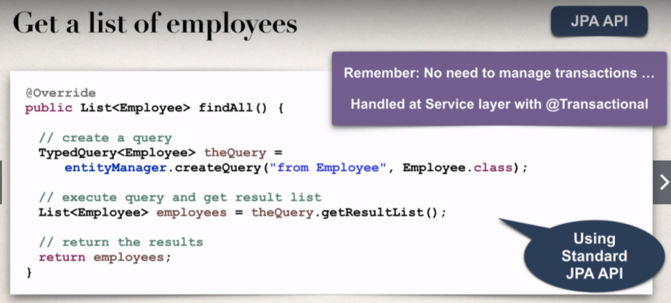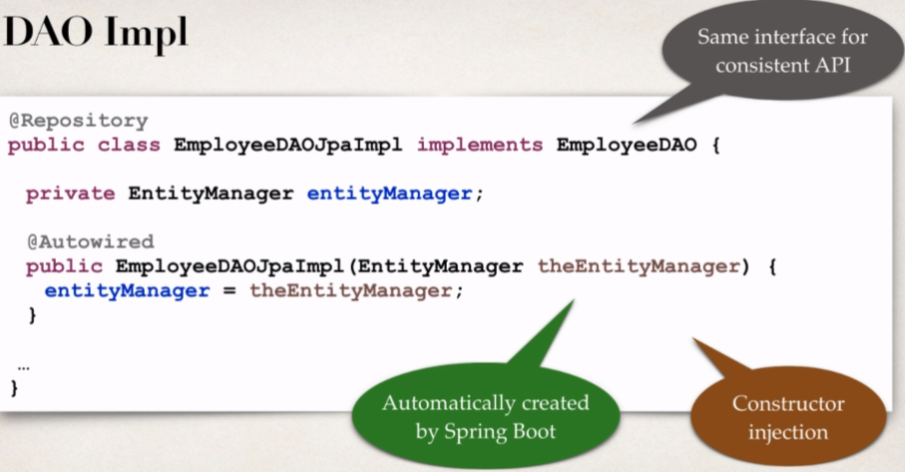

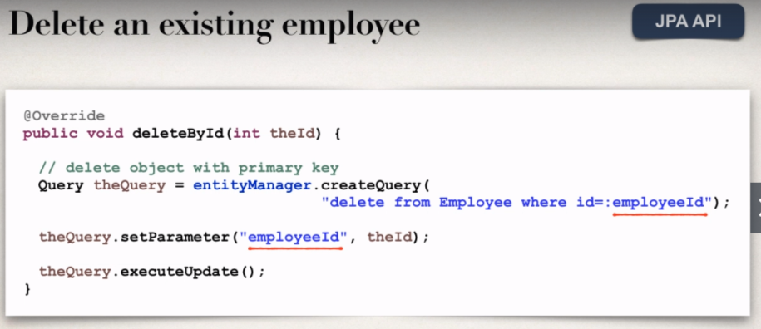



We will **Spring Data JPA:** [Java Project Link](https://github.com/000GEV744/Spring-Git/tree/main/23-spring-data-jpa-cruddemo)

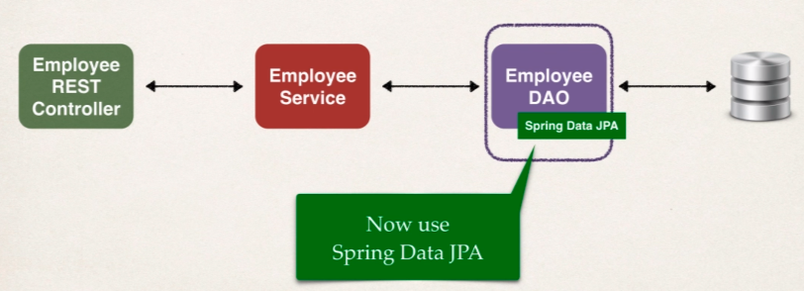

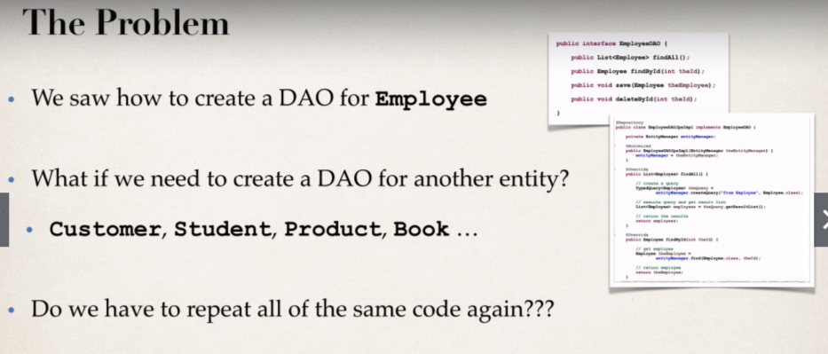

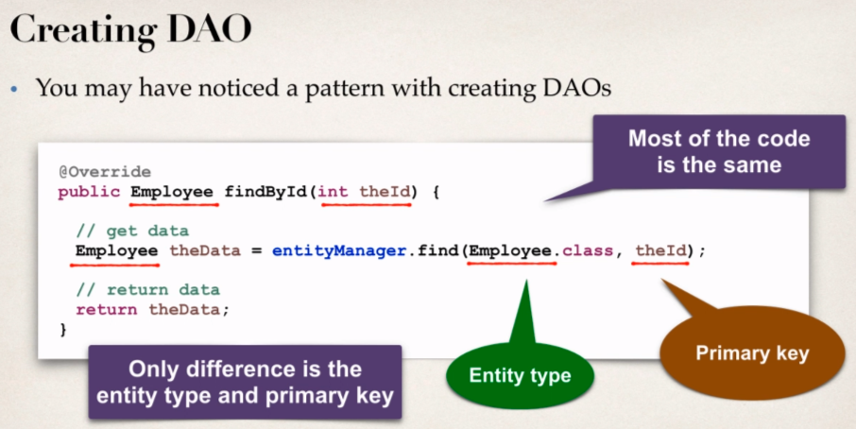

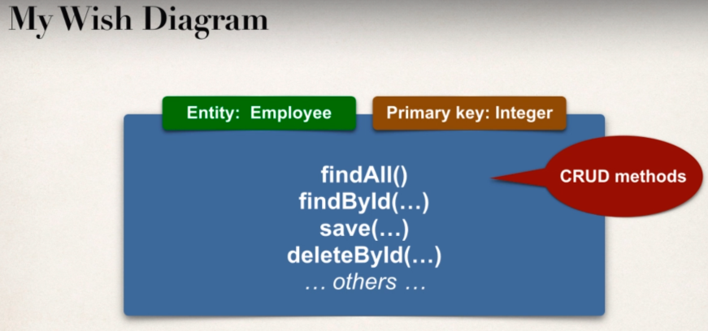

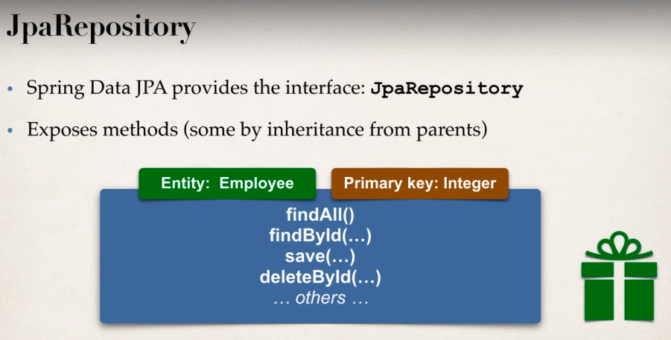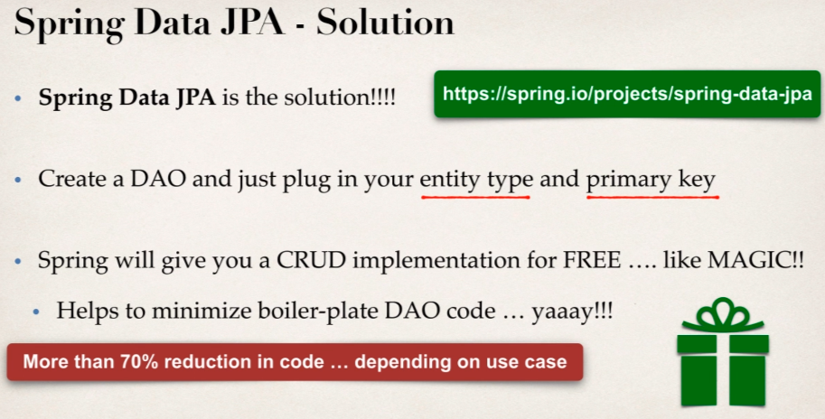

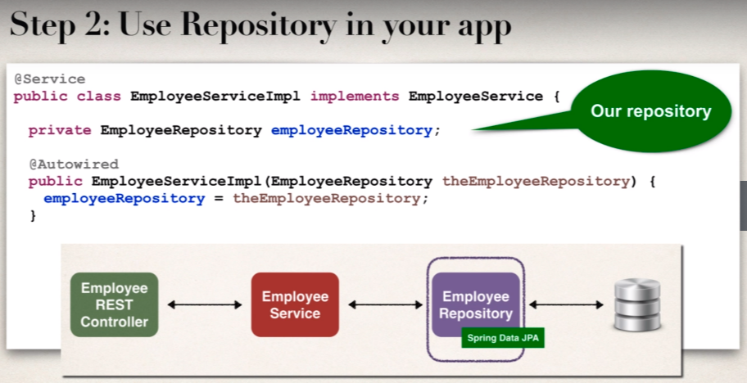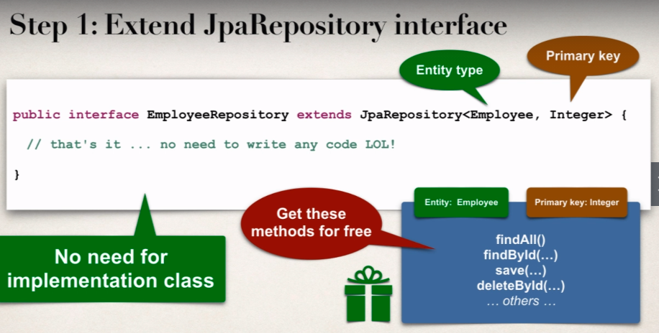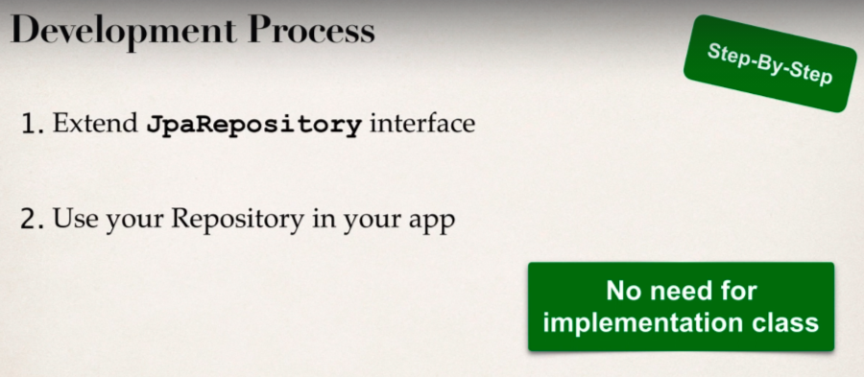

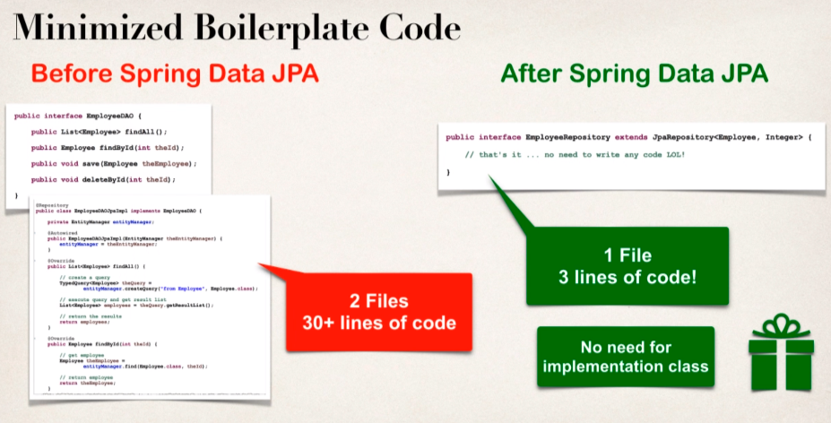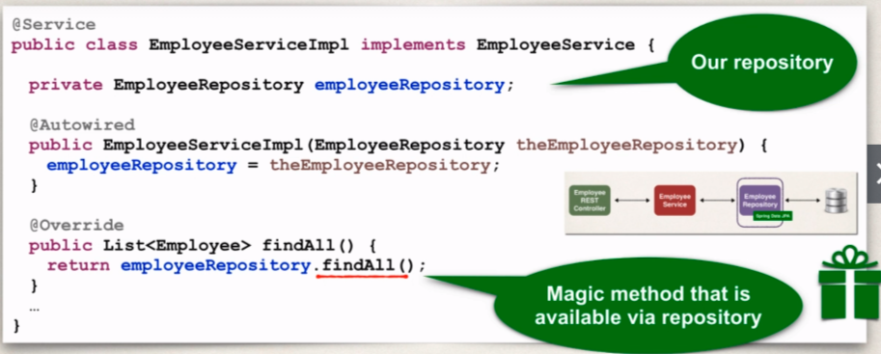

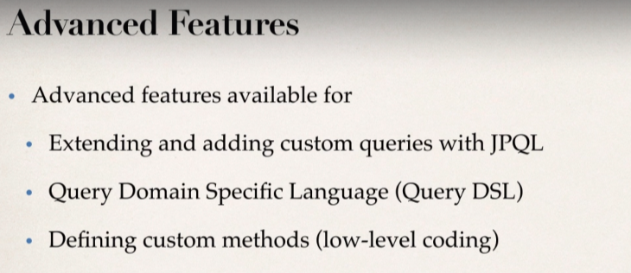

Visit for more info: [Link](https://docs.spring.io/spring-data/jpa/docs/current/reference/html/#repositories.query-methods.details)

**JPARepository** make use of **Optional**; so instead of checking for nulls we can make use of **Optional** to see if value is present or not.

@Override

**public** Employee findById(**int** theId) {

Optional<Employee> result = employeeRepository.findById(theId);

Employee theEmployee = **null**;

**if**(result.isPresent()) {

theEmployee= result.get();

}

**else** {

**throw** **new** RuntimeException("Did not find Employee id - "+theId);

}

**return** theEmployee;

 }

* Earlier we saw the magic of **Spring-data-JPA**
* 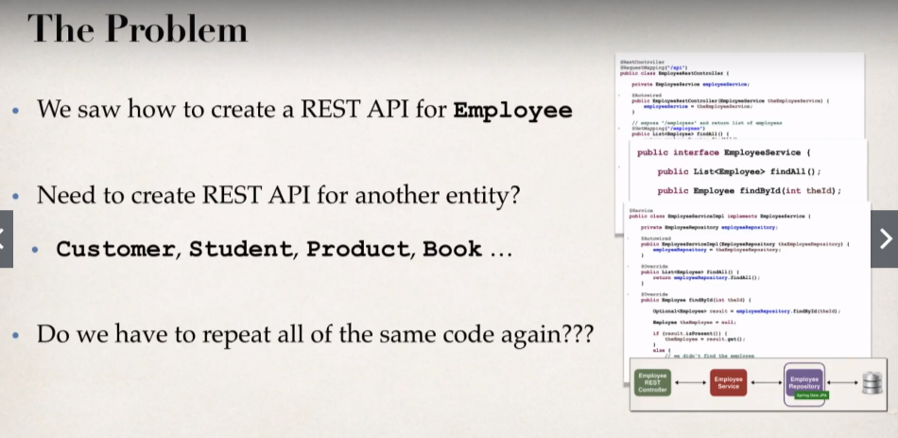This helped to eliminate Boilerplate code.

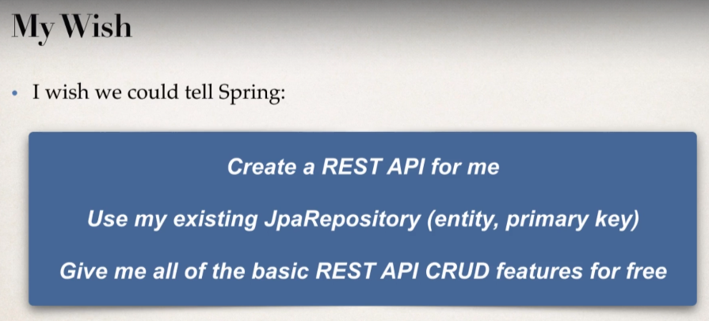

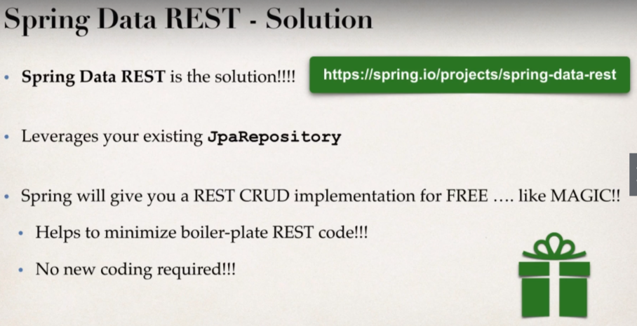

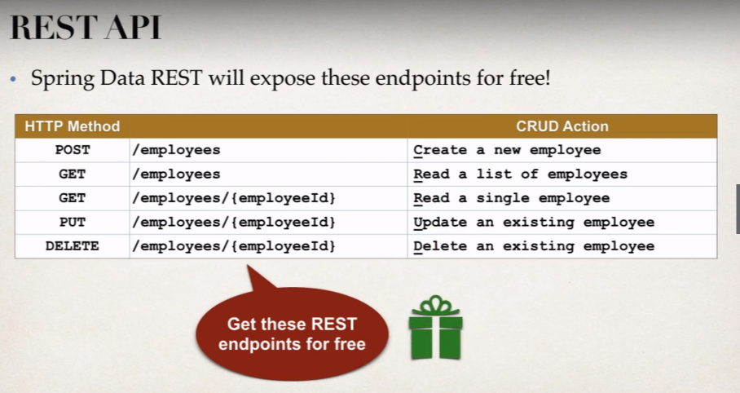

**Spring Data REST** – How Does it work?

* Spring Data REST will scan your project for JpaRepository.
* 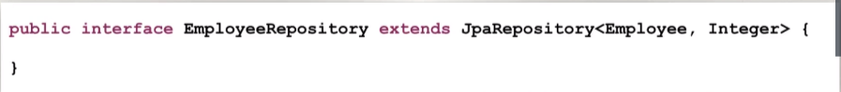Expose REST APIs for each entity for your JpaRepository.

**REST Endpoints:**

By Default, Spring Data REST will create the endpoints based on entity type.

Simple plurized form

* First Character of Entity type is lowercase
* Then just add an “s” to the entity.

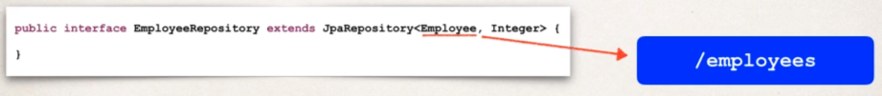**Development Process:**

1. 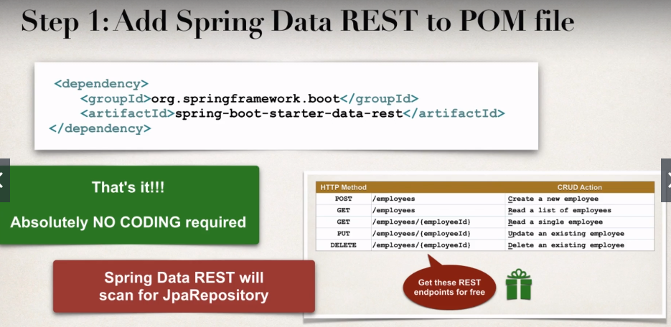Add Spring Data REST to your Maven POM file.

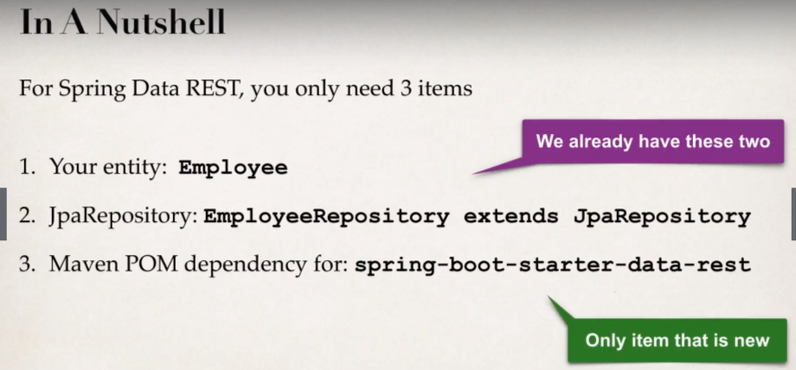

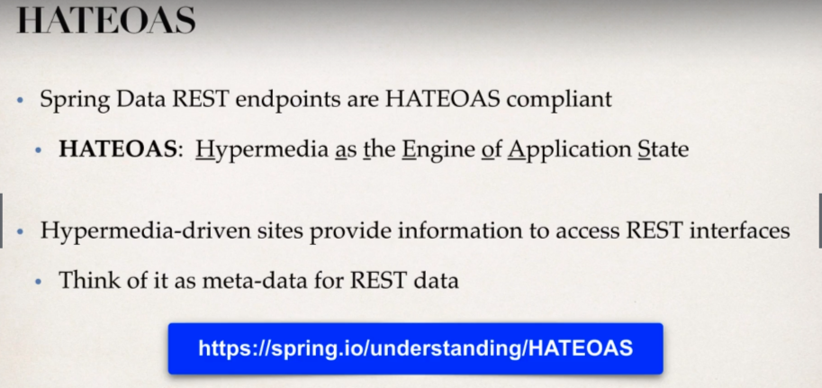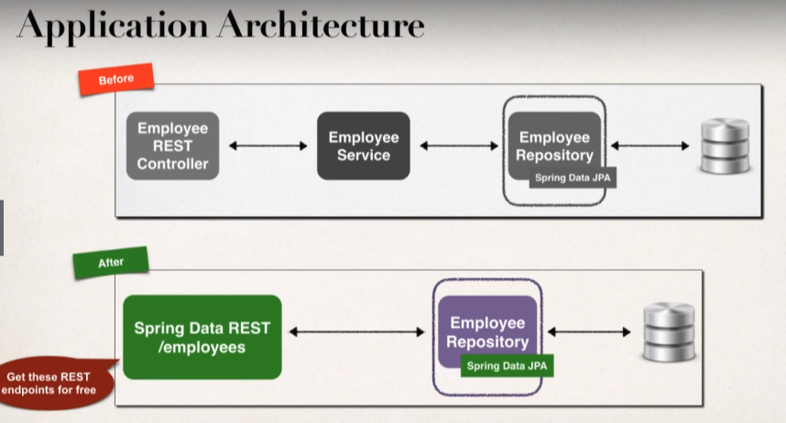

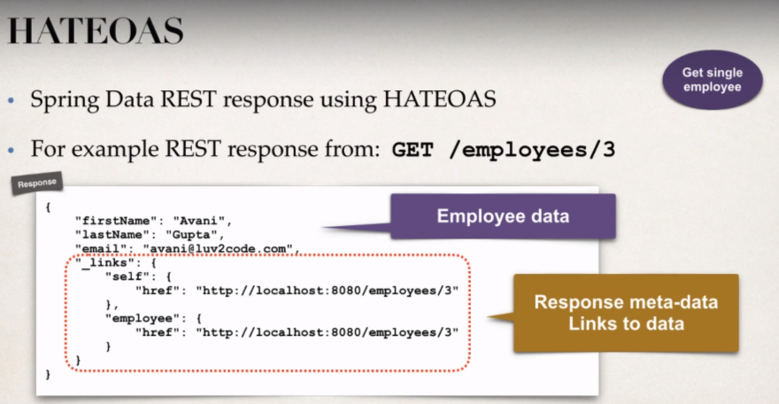

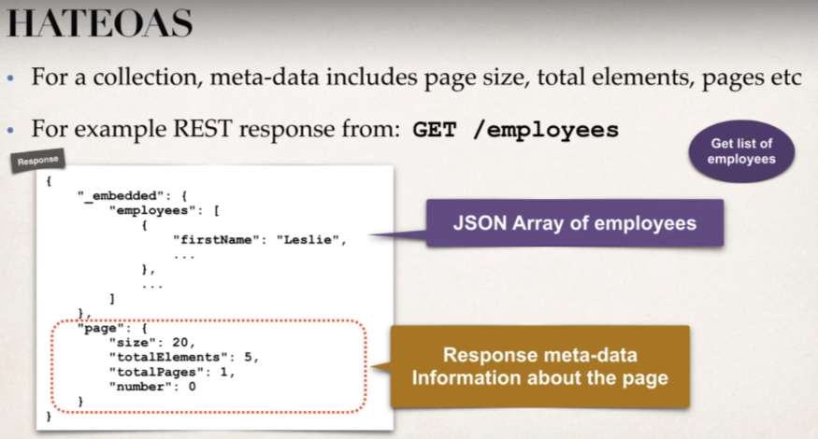

**Advanced Features:**

***Spring Data REST*** advanced features

* Pagination, sorting and searching.
* Extending and adding custom queries with JPQL.
* We can also customize the REST APIs by making use of Query Domain Specific Language (Query DSL).

**Customize the endpoint base path:**

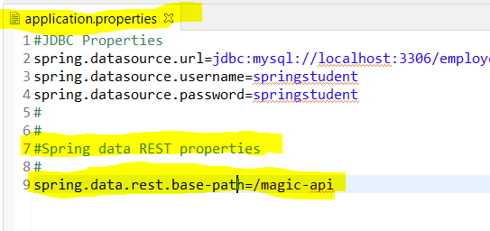

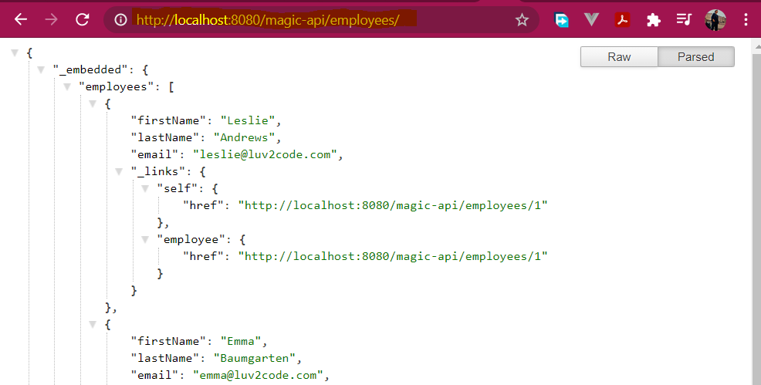

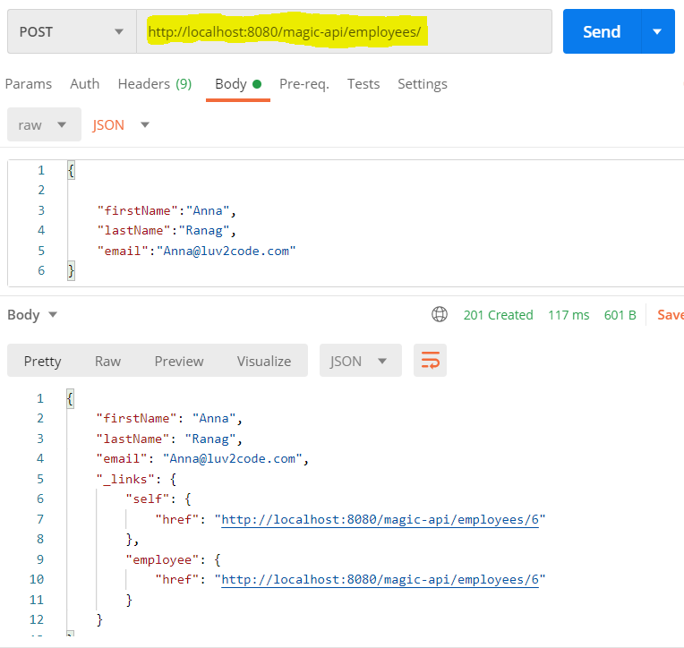

**Spring Data REST Configuration, Pagination and Sorting:**

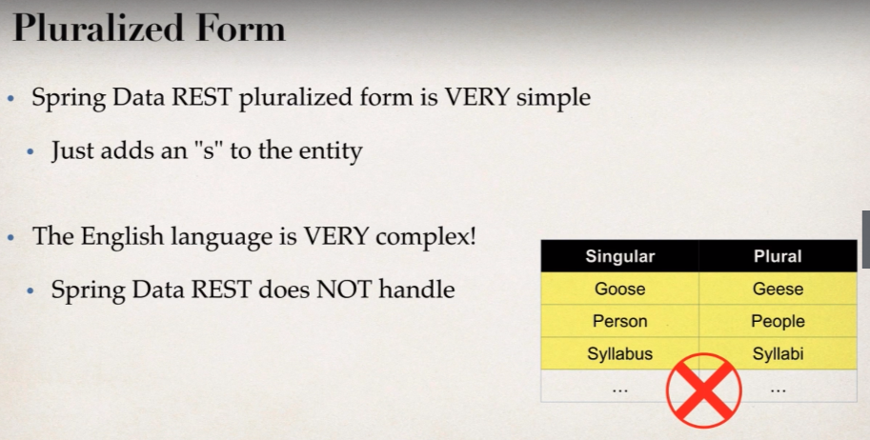

* Spring Data REST does not handle complex pluralized forms.
* In this case we need to specify plural name.
* What if we want to expose a different resource name?
* Instead of **/employees**, we want to expose **/members**

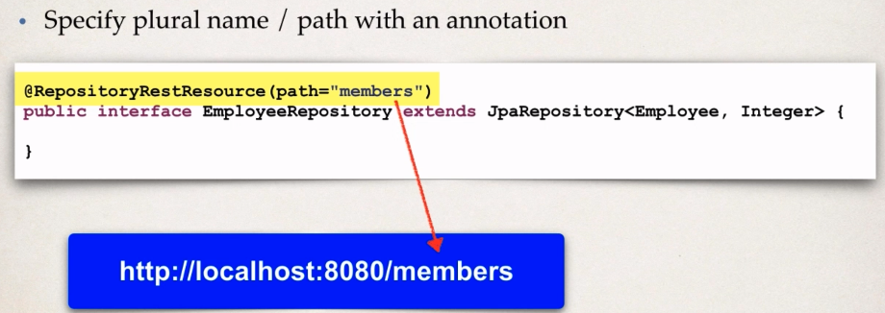**Solution:**



